**Workspace and Workflow**

**Photoshop CS6 workspace**

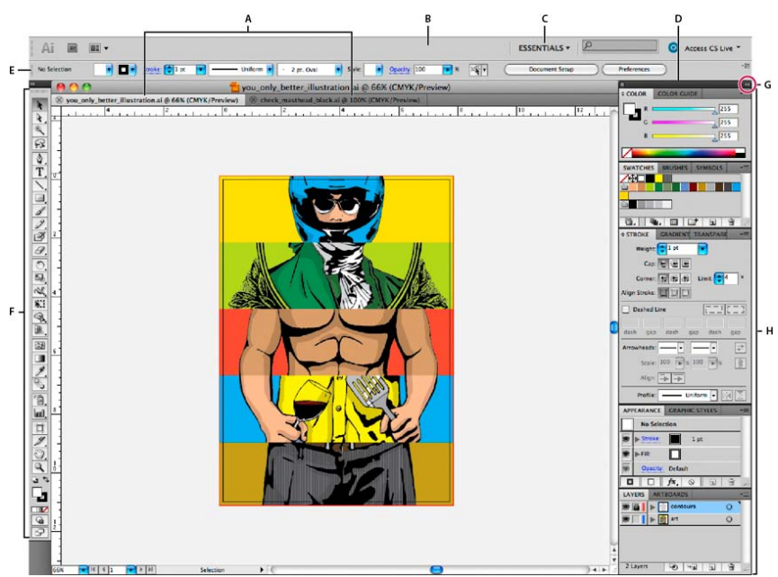

**A.** Tabbed Document windows **B.** Application bar **C.** Workspace switcher **D.** Panel title bar **E.** Control panel

**F.** Tools panel **G.** Collapse to Icons button **H.** Four panel groups in vertical dock

**Dock and undock panels**

A dock is a collection of panels or panel groups displayed together, generally in a vertical orientation. You dock and undock panels by moving them into and out of a dock.

* To dock a panel, drag it by its tab into the dock, at the top, bottom, or in between other panels.
* To dock a panel group, drag it by its title bar (the solid empty bar above the tabs) into the dock.
* To remove a panel or panel group, drag it out of the dock by its tab or title bar. You can drag it into another dock or make it free-floating.

**Move panels**

* To move a panel, drag it by its tab.
* To move a panel group, drag the title bar.

**A.** Title bar

**B.** Tab

**C.** Drop zone

**Add and remove panels**

* To remove a panel, right-click (Windows) or Control-click (Mac) its tab and then select Close, or deselect it from the Window menu.
* To add a panel, select it from the Window menu and dock it wherever you want.

**Resize panels**

* To minimize or maximize a panel, panel group, or stack of panels, double-click a tab. You can also double-click the tab area (the empty space next to the tabs).
* To resize a panel, drag any side of the panel. Some panels, such as the Color panel in Photoshop, cannot be resized by dragging.

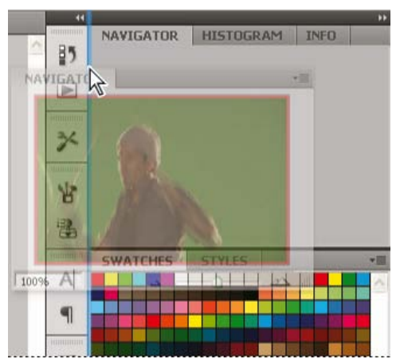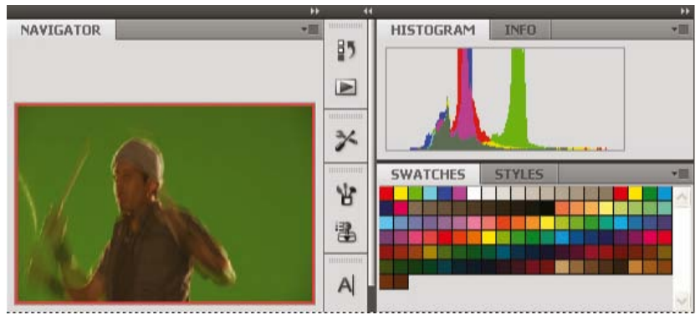

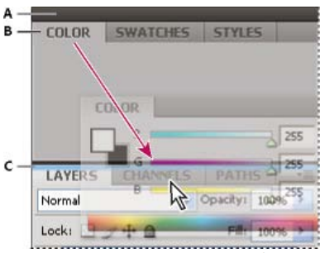

**Delete a custom workspace**

* Select Manage Workspaces from the workspace switcher in the Application bar, select the workspace, and then click Delete.
* Choose Window **>** Workspace **>** Delete Workspace, select the workspace, and then click Delete.

**Tools**

***Selection tools***

**The Quick Selection tool** lets you quickly “paint” a selection. using an adjustable round brush tip

**The Move tool** moves selections, layers, and guides.

**The marquee tools** make rectangular, elliptical, single row, and single column selections.

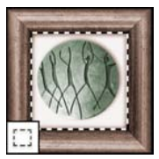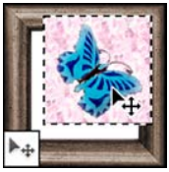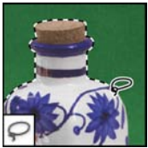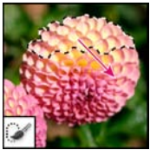

**The lasso tools** make freehand, polygonal (straight edged), and magnetic (snap to) selections

**The Magic Wand tool** selects similarly colored areas

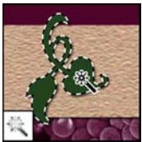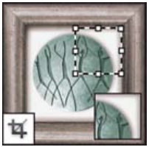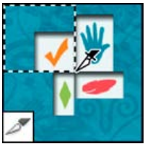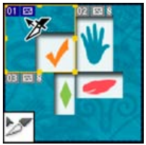

**The Crop tool** trims images.

**The Slice tool** creates slices.

**The Slice Select tool** selects slices.

***Crop and slice tools***

***Retouching tools***



**The Red Eye tool** removes the red reflection caused by a flash.



**The Patch tool** repairs imperfections in a selected area of an image using a sample or pattern.



**The Healing Brush tool** paints with a sample or pattern to repair imperfections in an image.



**The Spot Healing Brush tool** removes blemishes and objects.



**The Background Eraser tool** erases areas to transparency by dragging.



**The Eraser tool** erases pixels and restores parts of an image to a previously saved state.



**The Pattern Stamp tool** paints with part of an image as a pattern.



**The Clone Stamp tool** paints with a sample of an image.



**The Smudge tool** smudges data in an image.



**The Sharpen tool** sharpens soft edges in an image.



**The Blur tool** blurs hard edges in an image.



**The Magic Eraser tool** erases solid-colored areas to transparency with a single click.



**The Dodge tool** lightens areas in an image.



**The Sponge tool** changes the color saturation of an area.



**The Burn tool** darkens areas in an image.

***Painting tools***



**The Mixer Brush tool** Simulates realistic painting techniques such as blending canvas colors and varying paint wetness.



**The Color Replacement tool** replaces a selected color with a new color.



**The Pencil tool** paints hard-edged strokes.



**The Brush tool** paints brush strokes.



**The Paint Bucket tool** fills similarly colored areas with the foreground color.



**The gradient tools** create straight-line, radial, angle, reflected, and diamond blends between colors.



**The Art History brush tool** paints with stylized strokes that simulate the look of different paint styles, using a selected state or snapshot.



**The History Brush tool** paints a copy of the selected state or snapshot into the current image window.

***Drawing and type tools***



**The pen tools** let you draw smooth-edged paths.



**The type mask tools** create a selection in the shape of type.



**The path selection tools** make shape or segmentselections showing anchorpoints, direction lines, anddirection points.



**The typetools**create type on an image.



**The Custom Shape tool** makes customized shapes selected from a custom shape list.



**The shape tools** and Line tool draw shapes and lines in a normal layer or a shape layer.

***Navigation, notes, and measuring tools***



**The Note tool** makes notes that can be attached to an image.



**The Zoom tool** magnifies and reduces the view of an image.



**The Rotate View tool** non-destructively rotates the canvas.



**The Hand tool** moves an image within its window.



**The Eyedropper tool** samples colors in an image.

**The Count tool** counts objects in an image.

**The Ruler tool** measures distances, locations, and angles.

**The Color Sampler tool** displays color values for up to four areas.

**3D tools**



**The 3D Object Slide tool** moves the object laterally when you drag horizontally, or forward and back when you drag vertically.



**The 3D Object Pan tool** pans the object in the x or y direction.



**The 3D Object Roll tool** rotates the object around its z-axis.



**The 3D Object Rotate tool** rotates the object around its x-axis.



**The 3D Pan Camera tool** pans the camera in the x or y direction.



**The 3D Roll Camera tool** rotates the camera around the z-axis.



**The 3D Rotate Camera tool** orbits the camera in the x or y direction.



**The 3D Object Scale tool** scales the object larger or smaller.



**The 3D Zoom Camera tool** changes the field of view closer or farther away.



**The 3D Walk Camera tool** moves laterally when you drag horizontally, or forward and back when you drag vertically.

**Pixel Dimensions and Printed Image Resolution**



Same image at 72-ppi and 300-ppi;

inset zoom 200%

Pixel dimensions measure the total number of pixels along an image’s width and height. Resolution is the fineness of detail in a bitmap image and is measured in pixels per inch (ppi). The more pixels per inch, the greater the resolution. Generally, an image with a higher resolution produces a better printed image quality.

**Color modes**

RGB Color mode CMYK Color mode Lab Color mode Grayscale mode

Bitmap mode Duotone mode Indexed Color mode Multichannel mode

**Options Bar**

**Tool Presets**

**A.** Click the Tool Preset picker in the options bar to show the Tool Preset pop-up panel.

**B.** Select a preset to change the tool’s options to the preset, which applies each time you select the tool until you choose Reset Tool from the panel menu.

**C.** Deselect to show all tool presets; select to show presets for only the tool selected in the toolbox.

**Filter layers**

Filter layers options in the Layers panel

1. Gripper bar
2. Tool tip



**History panel**

1. Sets the source for the history brush
2. Thumbnail of a snapshot
3. History state
4. History state slider

**Layers panel**

**A.** Layers panel menu

**B**. Layer Group

**C**. Layer

**D.** Expand/Collapse Layer effects

**E.** Layer effect

**F.** Layer thumbnail

**Knockout**

* Farm logo with shallow knockout to Background layer





**Revealing layers with clipping masks**

* Content of the clipped layer (Potatoes) is only visible within the content of the base layer (Logo)

**Layer Masks**

1. Layer mask thumbnail
2. Vector mask thumbnail
3. Vector Mask Link icon
4. Add Mask



**Masks and Alpha Channels**

**A**. Opaque mask used to protect the background and edit the butterfly

**B.** Opaque mask used to protect the butterfly and color the background

**C.** Semitransparent mask used to color the background and part of the butterfly



Selection saved as an alpha channel in Channels panel

**Layer Effects and Styles**

1. Layer effects icon
2. Click to expand and show layer effects
3. ****Layer effects



**White balance controls**

1. Moving the Temperature slider to the right corrects a photo taken with a higher color temperature of light

1. Moving the Temperature slider to the left corrects a photo taken with a lower color temperature of light
2. ****Photo after color temperature adjustment

**Straighten an Image**



Rotate the image using the crop tool to straighten it



**Color panel**

1. Foreground color
2. Background color
3. Slider
4. Color ramp



**Adobe Color Picker**

**A**. Picked color

**B.** Original color

**C.** Adjusted color

**D.** Out-of-gamut alert icon

**E.** Not a web-safe color alert icon

**F.** Displays only web-safe colors

**G.** Color field

**H.** Color slider

**I.** Color values

**Curves adjustment**

**A.** On-image adjustment tool

**B.** Sample in image to set black point.

**C.** Sample in image to set gray point.

**D.** Sample in image to set white point.

**E.** Edit points to modify the curve.

**F.** Draw to modify the curve.

**G.** Curves presets menu

**H.** Set black point.

**I.** Set gray point.

**J.** Set white

**K.** point.

**L.** Show clipping.

**Transform Perspective While Cropping**

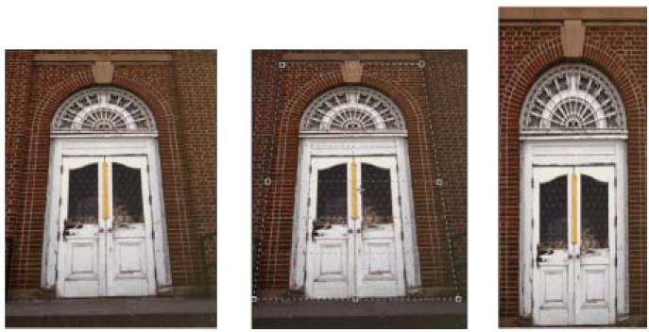

**A.** Original image **B.** Adjust cropping marquee to match the object’s edges **C.** Final image

**Warp**

**A.** Selecting the shape to be warped

**B.** Choosing a warp from the Warp Style pop-up   
 menu in the options bar

**C.** Result using several warp options





**A.** Original warp mesh

**B.** Adjusting the handles, mesh segments, and areas within the mesh

**Drawing modes**



1. Shape Layers
2. Paths
3. Fill Pixels

**Puppet Warp**

Moving a pin on the puppet mesh. Adjoining pins keep nearby areas intact.



Press Alt (Windows) to rotate the mesh around a selected pin.

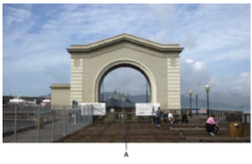**Content-aware scaling**

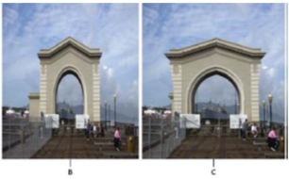

1. Original image
2. Scaled narrower
3. Scaled narrower, using content-aware scaling

**Brush panel**

1. Locked
2. Unlocked
3. Selected brush tip
4. Brush settings
5. Brush stroke preview
6. pop-up menu
7. Brush tip shapes (available when Brush Tip   
   Shape option is selected)
8. Brush options

**Pen tools**

**Draw straight line segments with the Pen tool**

Clicking Pen tool creates straight segments.

**Draw curves with the Pen tool**



1. Positioning Pen tool
2. Starting to drag (mouse button pressed)
3. Dragging to extend direction lines

**C curve**



1. Starting to drag second smooth point
2. Dragging away from previous direction line,   
    creating a C curve
3. Result after releasing mouse button
4. 

**S curve**



1. Starting to drag new smooth point
2. Dragging in same direction as previous   
    direction line, creating an S curve
3. Result after releasing mouse button

**Draw straight lines followed by curves**

1. Straight segment completed
2. Positioning Pen tool over endpoint (the   
    Convert Point icon appears only in   
    Illustrator and InDesign)
3. Dragging direction point



1. Positioning Pen tool
2. Dragging direction line
3. New curve segment completed

**Draw two curved segments connected by a corner**

1. Dragging a new smooth point
2. Pressing Alt/Option to split direction lines   
    while dragging, and swinging direction   
    line up
3. Result after repositioning and dragging a   
    third time

**Path segments, components, and points**

1. Curved line segment
2. Direction point
3. Direction line
4. Selected anchor point
5. Unselected anchor point

Converting a smooth point to a corner point



Smooth point and corner point



Adjusting a smooth point and a corner point

**Convert between smooth points and corner points**

Dragging a direction point out of a corner point to create a smooth point

Clicking a smooth point to create a corner point

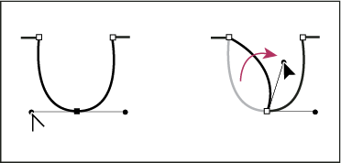

**Paths panel**

1. Saved path
2. Temporary work path
3. Vector mask path (appears only when shape layer is selected)

**Character panel**

1. Font Family
2. Font Size
3. Vertical Scale
4. Set Tsum option
5. Tracking
6. Baseline Shift
7. Language
8. Font Style
9. Leading
10. Horizontal scale
11. Kerning

**Paragraph panel**

1. Alignment and justification
2. Left indent
3. First line left indent
4. Space before paragraph
5. Hyphenation
6. Right indent
7. Space after

**Supported image sequence formats**

* BMP
* DICOM
* JPEG
* OpenEXR
* PNG
* PSD
* Targa
* TIFF
* Cineon and JPEG 2000 are supported if the plug-ins are installed.







**Color mode and bit depth**

* Grayscale: 8, 16, or 32 bpc
* RGB: 8, 16, or 32 bpc
* CMYK: 8 or 16 bpc
* Lab: 8 or 16 bpc

**Export layers to files**

You can export and save layers as individual files using a variety of formats, including PSD, BMP, JPEG, PDF, Targa, and TIFF.

* Choose File > Scripts > Export Layers To Files.

**Gradient Editor**

1. Panel menu
2. Opacity stop
3. Color stops
4. Adjust values or delete the selected opacity or color stop
5. ****Midpoint

**Photoshop print options and print**



1. Preview print
2. Set printer and print job options
3. Set paper orientation
4. Position and scale image
5. Specify prepress output options
6. Specify color management and proofing options

**Type Along or Inside A Path**



****Horizontal and vertical type on an open path.

Horizontal and vertical type on a closed path created by a shape tool

**Output Options**

1. Gradient tint bar
2. Label C. Registration marks
3. Progressive color bar
4. Corner crop mark
5. Center crop mark
6. Description
7. ****Star target

**3D Axis**

1. Selected tool
2. Minimize or maximize 3D Axis
3. Move item along axis
4. Rotate item
5. Compress or elongate item
6. ****Resize item
7. Displays Materials options
8. Selected material
9. Materials picker
10. Material Drop and Select tools
11. Texture map menu icon
12. Texture map types

**3D panel**

1. Display Scene, Meshes, Materials, or Lights options
2. Render presets menu
3. Customize render settings
4. Select texture to paint on
5. Cross section settings
6. Toggle overlays
7. Add new light
8. Delete light



**3D Materials settings**

**Photoshop Shortcuts**

| Windows Shortcut | Result |
| --- | --- |
| V | * Move tool |
| M | * Rectangular Marquee tool * Elliptical Marquee tool |
| L | * Lasso tool * Polygonal Lasso tool * Magnetic Lasso tool |
| W | * Magic Wand tool * Quick Selection tool |
| C | * Crop tool * Slice tool * Slice Select tool |
| I | * Eyedropper tool * Color Sampler tool * Ruler tool * Note tool * Count tool |
| J | * Spot Healing Brush tool * Healing Brush tool * Patch tool * Red Eye tool |
| B | * Brush tool * Pencil tool * Color Replacement tool * Mixer Brush tool |
| S | * Clone Stamp tool * Pattern Stamp tool |
| Y | * History Brush tool * Art History Brush tool |
| E | * Eraser tool * Background Eraser tool * Magic Eraser tool |
| G | * Gradient tool * Paint Bucket tool |
| O | * Dodge tool * Burn tool * Sponge tool |
| P | * Pen tool * Freeform Pen tool |
| T | * Horizontal Type tool * Vertical Type tool * Horizontal Type mask tool * Vertical Type mask tool |
| A | * Path Selection tool * Direct Selection tool |
| U | * Rectangle tool * Rounded Rectangle tool * Ellipse tool * Polygon tool * Line tool * Custom Shape tool |
| H | * Hand tool |
| R | * Rotate View tool |
| Z | * Zoom tool |
| F | * Toggle (forward) between Standard * screen mode, Full screen mode with * menu bar, and Full screen mode |
| Shift + F | * Toggle (backward) between Standard * screen mode, Full screen mode with * menu bar, and Full screen mode |
| Double-click Zoom tool or  Ctrl + 1 | * Magnify 100% |
| Spacebar | * Switch to Hand tool (when not in text-edit mode) |
| Shift + Enter in Navigator panel zoom  percentage box | * Apply zoom percentage, and keep zoom * percentage box active |
| Spacebar-drag, or drag view area box in  Navigator panel | * Scroll image with Hand tool |
| Control + Z | * Undo/Redo |
| Control + Shift + Z | * Step forward |
| Control + Alt + Z | * Step backward |
| Control + + (plus) | * Zoom in |
| Control + - (hyphen) | * Zoom out |
| Control + 0 (zero), Double-click Hand tool | * Fit in view |
| ] / [ | * Increase/decrease brush size |
| Shift + ] / Shift + [ | * Increase/decrease brush hardness |
| Control + D | * Deselect all |
| Control + H | * Hide selection and planes |
| Arrow keys | * Move selection 1 pixel |
| Shift + arrow keys | * Move selection 10 pixels |
| Control + C | * Copy |
| Control + V | * Paste |
| Control + Shift + T | * Repeat last duplicate and move |
| Control + Alt-drag | * Create a duplicate of the selection as a * floating selection |
| I | * White Balance tool |
| S | * Color Sampler tool |
| K | * Adjustment Brush tool |
| Any marquee tool (except single column  and single row) + spacebar-drag | * Reposition marquee while selecting |
| Any selection tool + Shift-drag | * Add to a selection |
| Any selection tool + Alt-drag | * Subtract from a selection |
| Any selection tool (except Quick Selection  tool) + Shift-Alt-drag | * Intersect a selection |
| Move tool + Alt-drag selection | * Move copy of selection |
| Shift-drag guide | * Snap guide to ruler ticks (except when * View > Snap is unchecked) |
| Pen (any Pen tool), Path Selection or  Direct Selection tool + Control + Alt-drag | * Duplicate a path |
| Shift-click | * Create a new text layer, when a text layer * is selected in the Layers panel |
| Alt + Shift | * Show Clone Source (overlays image) |
| Alt + Shift + arrow keys | * Nudge Clone Source |
| Alt + Shift + < or > | * Rotate Clone Source |
| Alt + Shift + [ or ] | * Scale (increase or reduce size) Clone * Source |
| Alt-click color in color bar | * Select background color |
| Control + G | * Group layers |
| Control + Shift + G | * Ungroup layers |
| Control + Alt + G | * Create/release clipping mask |
| Control + Alt + A | * Select all layers |
| Control + Shift + E | * Merge visible layers |
| Control + Shift + [ or ] | * Move layer to bottom or top |
| Double-click layer | * Edit layer style |
| Shift-click vector mask thumbnail | * Disable/enable vector mask |
| Shift-click layer/filter mask thumbnail | * Toggle layer mask on/off * Toggle filter mask on/off |
| Double-click type layer thumbnail | * Select all type; temporarily select Type * tool |
| Double-click the filter effect | * Edit filter settings |
| Alt-click Add Layer Mask button | * Create layer mask that hides all/selection |
| Shift-click | * Select/deselect multiple contiguous layer * comps |
| Control-click | * Select/deselect multiple discontinuous * layer comps |